A2607-Eur-England-East Anglia-Rune-Calendar-Jawbone of Porpoise-400-600 CE

 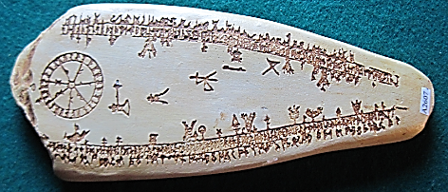

Fig. 1. Woodcut of a runic calendar engraved on a porpoise jawbone discovered in the 17th century with “Old-Northern [i.e. Frisian] and provincial English runes” after (Worn:1643; reprinted in Stephens: 1884: 159). Fig. 2. Museum replica of runic calendar after (Worn:1643; reprinted in Stephens: 1884: 159).

**Case no.:**

**Accession Number:**

**Formal Label:**

**Display Description:**

**Ole Worm** (13 May 1588 – 31 August 1654), a Danish antiquary, physician and natural historian, published (Worm:1643) this woodcut of an English runic calendar engraved on a porpoise jawbone from which the resin replica has been made. The woodcut shows the winter season lasting from 14 October to 13 April. The summer season on the other side was never copied and is now lost. Worm was a prolific collector and his “Cabinet of Curiosities” (Fig. 3, below) was a marvel for all who saw it.

“Rune” is derived from a Frisian language verb “*reauntsje*”, which means softly whispering.  In Frisia, which comprises the North Sea coast of Netherlands, Frisia and northern Germany, Anglo-Saxons before 400 CE developed a runic alphabet or futhorc (= *fuþorc*)

of 33 characters. This was an expansion of the so-called Elder Futhark (=*fuþark*),  that developed among the Northwest Germanic dialects from the 2nd to the 8th centuries.



Fig. 3. Blue circles compiled from rune finds in England, after <http://www.mygen.com/users/outlaw/images/Runes_England_pre650AD.jpg>;

Red circles and red squares compiled from Frisian artifacts and Frisian DNA after [http://webspace.webring.com/people/h...h_frisian.html](http://webspace.webring.com/people/hf/farthegn/dna_english_frisian.html)

In 2002, one set of DNA was taken by researchers from University College London from over a hundred males with long-standing residence in East Anglia (Bourne**,** Lincolnshire; North Walsham and Fakenham, Norfolk and central England (Southwell, Nottinghamshire and Ashbourne, Derbyshire). By comparison, a second set of DNA was taken from 94 males from males with long-standing residence in Friesland, Netherlands. The two sets of DNA (red squares) were virtually indistinguishable. Frisian sites (red circles) in England on the map in Fig. 3 include household items such as pottery, dating to the period 400-600 CE, and by this fact a mass emigration from Friesland to East Anglia is indicated at this time-horizon. In addition, Frisian-Anglo Saxon runes (blue circles) have been found in proximity to these households at a similar time-horizon. This time-horizon potentially lowers the projected date on the porpoise jawbone with Frisian-Anglo Saxon runes by 400 to 700 years (Stephens 1884) and potentially links it to the immigration to East Anglia.

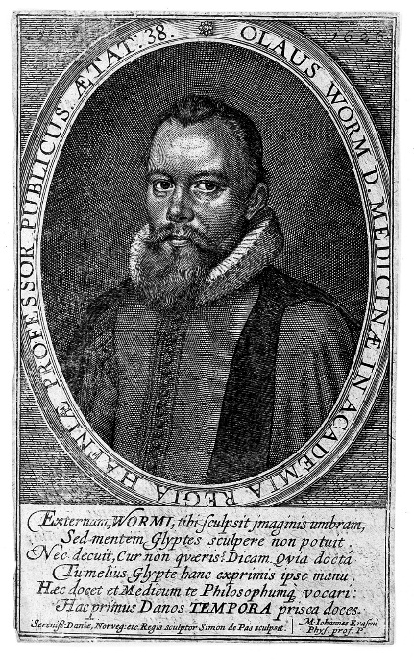 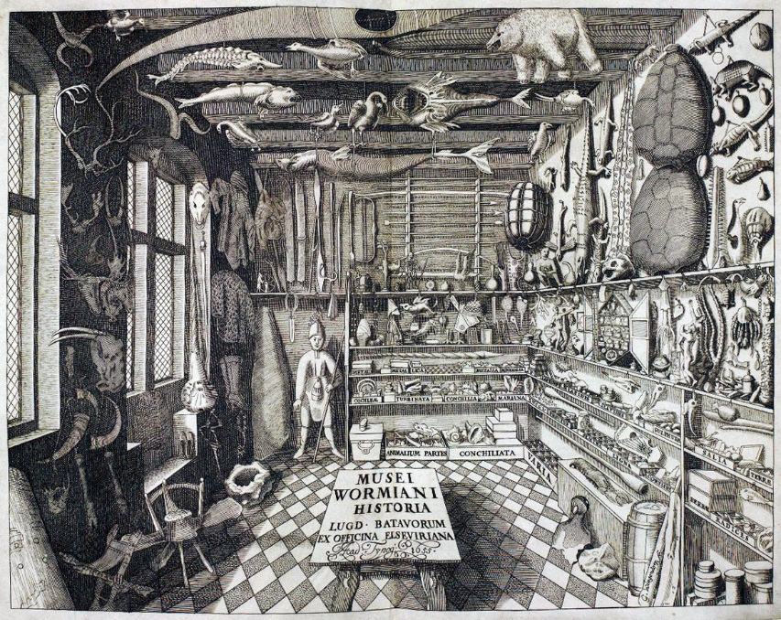

Fig. 3. Frontispiece portrait of the author by Carol van Mander, after (Worm 1633). See <https://upload.wikimedia.org/wikipedia/commons/3/3d/Portrait_of_Ole_Worm%2C_%22Fasti_Danici%22%2C_1626_Wellcome_L0008182.jpg>

Fig. 4. Frontispiece engraved by G. Wingendorp, after (Worm 1655). https://upload.wikimedia.org/wikipedia/commons/f/f5/Musei_Wormiani_Historia.jpg

**LC Classification:** PD2002

**Date or Time Horizon:** 1050 CE

**Geographical Area:** East Anglia

**Map:**

**GPS coordinates:**

**Cultural Affiliation:**

**Media:**

**Dimensions:**

**Weight:**

**Condition:**

**Provenance:**

**Discussion:**

**References:**

Bammesberger, A. ed. (1991). “Old English Runes and their Continental Background”, Anglistische Forschungen, Heidelberg, **217***.*

Hines, J. 1990. “The Runic Inscriptions of Early Anglo-Saxon England”, in Bammesberger, A, Britain 400–600: Language and History, Heidelberg, pp. 437–56*.*

Looijenga, J. H. 1997. Runesaround the North Sea and on the Continent AD 150–700, dissertation, Gröningen University.

Page, Raymond Ian.1999. An introduction to English runes (2nd ed.), Woodbridge: Boydell

Stephens, George. 1884. *Handbook of the old-northern runic monument of Scandinavia and England, now first collected and deciphered****.*** Edinburgh: Williams and Norgate ; Kjøbenhavn: Lynge.

Worm, Ole. 1633. *Fasti Danici: universam tempora computandi rationem antiqvitus in Dania et vicinis regionibus observatam libris tribus exhibentes/ ex varijs patriae antiqvitatibus et autoribus fide dignis eruti, ac in lucem emisi ab Olao Worm.*Hafniae : Apud Salomonem Sartorium Regium et Academie Typographii.

## Worm, Ole. 1643. *Danicorum monumentorum libri sex / e spissis antiquitatum tenebris et in Dania ac Norvegia extantibus ruderibus eruti ab Olao Worm.* Hafniæ, apud Ioachimum Moltkenium.

Worm, Ole. 1655**. *Museum Wormianum, Seu Historia Rerum Rariorum, Tam Naturalium, quam Artificialium, tam Domesticarum, quam Exoticarum, quae Hafniae Danorum in aedibus Authoris servantur: Variis & accuratis Iconibus illustrata*** . Amstelodami: Apud Ludovicum & Danielem Elzevirios.

A [**Runic**](https://en.wikipedia.org/wiki/Runic) **calendar** (also *Rune staff* or *Runic Almanac*) is a [perpetual calendar](https://en.wikipedia.org/wiki/Perpetual_calendar), variants of which have been used in Northern Europe until the 19th century.

The calendar is based on the 19-year-long [Metonic cycle](https://en.wikipedia.org/wiki/Metonic_cycle), correlating the Sun and the Moon. Runic calendars were written on [parchment](https://en.wikipedia.org/wiki/Parchment) or carved onto [staves](https://en.wiktionary.org/wiki/stave) of wood, bone, or horn. The oldest one known, and the only one from the [Middle Ages](https://en.wikipedia.org/wiki/Middle_Ages), is the [Nyköping](https://en.wikipedia.org/wiki/Nyk%C3%B6ping) staff from [Sweden](https://en.wikipedia.org/wiki/Sweden), believed to date from the 13th century. Most of the several thousand which survive are wooden calendars dating from the 16th and the 17th centuries. During the 18th century, the Runic calendars had a renaissance, and around 1800, such calendars were made in the form of tobacco boxes in brass.

A typical Runic calendar consisted of several horizontal lines of symbols, one above the other.

Special days like [solstices](https://en.wikipedia.org/wiki/Solstices), [equinoxes](https://en.wikipedia.org/wiki/Equinoxes), and celebrations (including [Christian](https://en.wikipedia.org/wiki/Christian) holidays and [feasts](https://en.wikipedia.org/wiki/Feasts)) were marked with additional lines of symbols.

The calendar does not prove knowledge of the length of the [tropical year](https://en.wikipedia.org/wiki/Tropical_year) or of the occurrence of [leap years](https://en.wikipedia.org/wiki/Leap_year). It is set at the beginning of each year by observing the first [full moon](https://en.wikipedia.org/wiki/Full_moon) after the [winter solstice](https://en.wikipedia.org/wiki/Winter_solstice). The first full moon also marked the date of [Disting](https://en.wikipedia.org/wiki/Disting), a [pagan](https://en.wikipedia.org/wiki/Pagan) feast and a [fair](https://en.wikipedia.org/wiki/Fair) day.

Marks[[edit](https://en.wikipedia.org/w/index.php?title=Runic_calendar&action=edit&section=1)]

[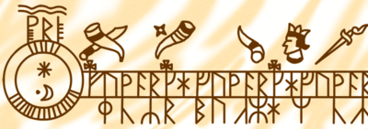](https://en.wikipedia.org/wiki/File:Runic_calendar_diagram.gif)

Detail of a Runic Calendar, showing the three rows of symbols. Based on page 104 of [F.E. Farwerck](https://nl.wikipedia.org/wiki/Frans_Eduard_Farwerck)'s [*Noord-Europese Mysteriën*](https://en.wikipedia.org/w/index.php?title=Noord-Europese_Mysteri%C3%ABn&action=edit&redlink=1) [[1]](http://www.gangleri.nl/articles/59/rune-calendars)

On one line, 52 weeks of 7 days were laid out using 52 repetitions of the first seven runes of the [Younger Futhark](https://en.wikipedia.org/wiki/Younger_Futhark). The runes corresponding to each [weekday](https://en.wikipedia.org/wiki/Weekday) varied from year to year.

On another, many of the days were marked with one of 19 symbols representing the 19 [Golden numbers](https://en.wikipedia.org/wiki/Golden_numbers), the years of the [Metonic cycle](https://en.wikipedia.org/wiki/Metonic_cycle" \o "Metonic cycle). In early calendars, each of the 19 years in the cycle was represented by a rune; the first 16 were the 16 runes of the [Younger Futhark](https://en.wikipedia.org/wiki/Younger_Futhark), plus special runes for the remaining three years: [Arlaug](https://en.wikipedia.org/wiki/Arlaug" \o "Arlaug) (Golden Number 17), [Tvimadur](https://en.wikipedia.org/wiki/Tvimadur" \o "Tvimadur) (Golden Number 18), and [Belgthor](https://en.wikipedia.org/wiki/Belgthor" \o "Belgthor) (Golden Number 19). The new moon would fall on that day during that year of the cycle. For example, in the 18th year of the cycle, the new moons would fall on all the dates marked with Tvimadur, the symbol for year 18. Later calendars used [Pentadic numerals](https://en.wikipedia.org/wiki/Pentadic_numerals" \o "Pentadic numerals) for the values 1–19.

A version using [Latin alphabet](https://en.wikipedia.org/wiki/Latin_alphabet) for weekdays and [Arabic numerals](https://en.wikipedia.org/wiki/Arabic_numerals) for the golden numbers [was printed](https://en.wikipedia.org/wiki/Incunabula) in 1498 as part of the *[Breviarium Scarense](https://en.wikipedia.org/w/index.php?title=Breviarium_Scarense&action=edit&redlink=1" \o "Breviarium Scarense (page does not exist))*.[[1]](https://en.wikipedia.org/wiki/Runic_calendar#cite_note-Scarense-1)

**Additional runes**[[edit](https://en.wikipedia.org/w/index.php?title=Runic_calendar&action=edit&section=2)]

Because this system needed 19 runes to represent the 19 [golden numbers](https://en.wikipedia.org/wiki/Golden_numbers) which stood for the 19 years of the perpetual calendar's cycle, the [Younger Futhark](https://en.wikipedia.org/wiki/Younger_Futhark), a [Runic alphabet](https://en.wikipedia.org/wiki/Runic_alphabet), was insufficient, having only 16 characters. The solution devised was to add three special runes to represent the numbers above 16: Arlaug (Golden Number 17), Tvimadur (*tvímaður*, Golden Number 18), and Belgthor (Golden Number 19).

* [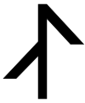](https://en.wikipedia.org/wiki/File:Arlaug.svg)

Arlaug, Runic calendar rune number 17.

* [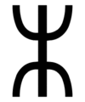](https://en.wikipedia.org/wiki/File:Tvimadur.gif)

Tvimadur, Runic calendar rune number 18.

* [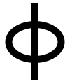](https://en.wikipedia.org/wiki/File:Belgthor.svg)

Belgthor, Runic calendar rune number 19.

Primstav[[edit](https://en.wikipedia.org/w/index.php?title=Runic_calendar&action=edit&section=3)]

[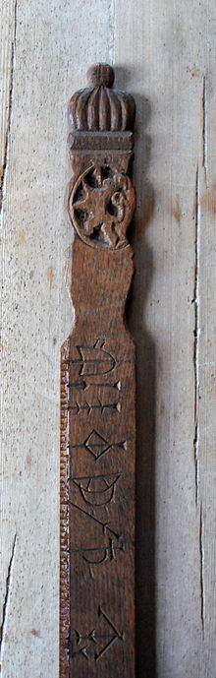](https://en.wikipedia.org/wiki/File:Primstav_2.jpg)

Primstav from [Hallingdal](https://en.wikipedia.org/wiki/Hallingdal" \o "Hallingdal) with [coat of arms of Norway](https://en.wikipedia.org/wiki/Coat_of_arms_of_Norway), 17th century.

A **primstav** (translation: prime staff) is the ancient [Norwegian](https://en.wikipedia.org/wiki/Norwegian_people) calendar stick. These were engraved with images instead of runes. The images depicted the different nonmoving religious holidays. The oldest primstav still in existence is from 1457 and is exhibited at [Norsk Folkemuseum](https://en.wikipedia.org/wiki/Norsk_Folkemuseum" \o "Norsk Folkemuseum).

[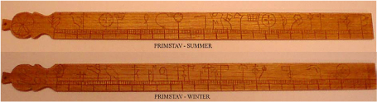](https://en.wikipedia.org/wiki/File:Primstav.jpg)

A Norwegian primstav, carved in wood.

Modern use[[edit](https://en.wikipedia.org/w/index.php?title=Runic_calendar&action=edit&section=4)]

Adherents of the [Estonian](https://en.wikipedia.org/wiki/Estonia) ethnic religion (*[maausk](https://en.wikipedia.org/wiki/Maausk" \o "Maausk)*) have published Runic calendars ([Estonian](https://en.wikipedia.org/wiki/Estonian_language): *sirvilauad*) every year since 1978. During the [Soviet](https://en.wikipedia.org/wiki/Soviet_Union) occupation, it was an illegal [*samizdat*](https://en.wikipedia.org/wiki/Samizdat) publication.[[2]](https://en.wikipedia.org/wiki/Runic_calendar#cite_note-2)

See also[[edit](https://en.wikipedia.org/w/index.php?title=Runic_calendar&action=edit&section=5)]

* [Computus Runicus](https://en.wikipedia.org/wiki/Computus_Runicus)
* [Germanic calendar](https://en.wikipedia.org/wiki/Germanic_calendar)
* [Method of Lunar Distances](https://en.wikipedia.org/wiki/Method_of_Lunar_Distances)
* [Nationalencyklopedin](https://en.wikipedia.org/wiki/Nationalencyklopedin)
* [Scythe sword](https://en.wikipedia.org/wiki/Scythe_sword)

References[[edit](https://en.wikipedia.org/w/index.php?title=Runic_calendar&action=edit&section=6)]

* 1. [**Jump up^**](https://en.wikipedia.org/wiki/Runic_calendar#cite_ref-Scarense_1-0) *Brinolf Gerlaksson, bishop of Skara (commissioned by) (1498). [Breviarium Scarense](http://istc.bl.uk/search/search.html?operation=record&rsid=655644&q=0). Nuremberg: Georg Stuchs. pp. 2–13. Retrieved 2010-06-20.*
  2. [**Jump up^**](https://en.wikipedia.org/wiki/Runic_calendar#cite_ref-2) [Sirvilauad loevad aega](http://www.maaleht.ee/2009/01/08/kultuur/4151-sirvilauad-loevad-aega)

Further reading[[edit](https://en.wikipedia.org/w/index.php?title=Runic_calendar&action=edit&section=7)]

* Becker, Alfred: A Magic Spell "powered by" a Lunisolar Calendar, *Asterisk, A Quarterly Journal of Historical English Studies*, 15 (2006)
* Becker, Alfred: *Franks Casket. Zu den Bildern und Inschriften des Runenkästchens von Auzon* (Regensburg 1973)